Scenario 7: without IAM permission can user access S3 bucket?
NO, IAM + Bucketpolicy = Access to bucket.
Here we can see that testuser don’t have access to s3, lets grant him via resource based policy
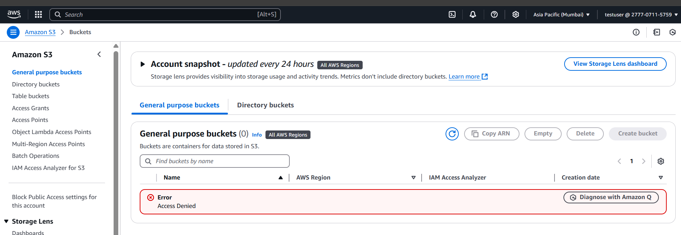
Step 1: As an admin account go the s3 bucket
Step 2: select the bucket which you need to allow testuser can readaccess.
Step 3: go to bucket policy > edit bucket policy > click on policy generator
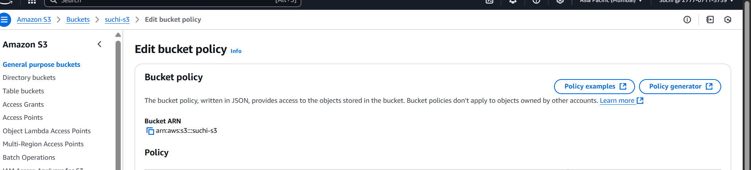
Step 4: create the policy for listbucket and getbucket and click generate policy
verify that the 'Resource' in each statement correctly specifies the bucket or objects within the bucket. For example:
- For the bucket: 'arn:aws:s3:::suchi-s3'
- For objects in the bucket: 'arn:aws:s3:::suchi-s3/*' or arn:aws:s3:::suchi-s3/demo/*
Since we are applying policy to bucket use - 'arn:aws:s3:::suchi-s3'
Step 5: Copy the generated policy and paste in the JSON
{
"Version": "2012-10-17",
"Id": "Policy1746206448277",
"Statement": [
{
"Sid": "Stmt1746206193518",
"Effect": "Allow",
"Principal": {
"AWS": "arn:aws:iam::277707115759:user/testuser"
},
"Action": "s3:GetObject",
"Resource": "arn:aws:s3:::suchi-s3/demo/*"
},
{
"Sid": "Stmt1746206223274",
"Effect": "Allow",
"Principal": {
"AWS": "arn:aws:iam::277707115759:user/testuser"
},
"Action": "s3:ListBucket",
"Resource": "arn:aws:s3:::suchi-s3"
}
]
}

Step 6: Let’s Validate under testuser account.

- User wont be able to access the bucket.
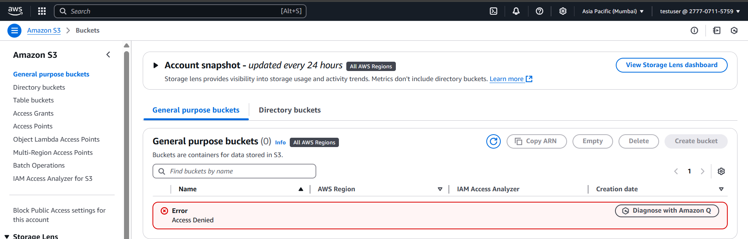

- User won’t be able to bucket of account B too.
